Tasks on Ansible – 03

1) Write a single ansible playbook which will install apache and nginx. Note: Playbook should not be hardcoded and pass the variables from different file.

Install Apache and Nginx Using Vars file.

Hosts setup:

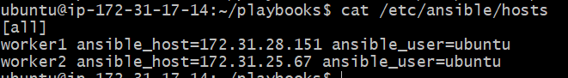

vars.yml
packages:
- apache2
- nginx

html_message_apache: "hi this a playbook test apache2 {{ inventory_hostname }}"
html_message_nginx: "hi this a playbook test nginx {{ inventory_hostname }}"

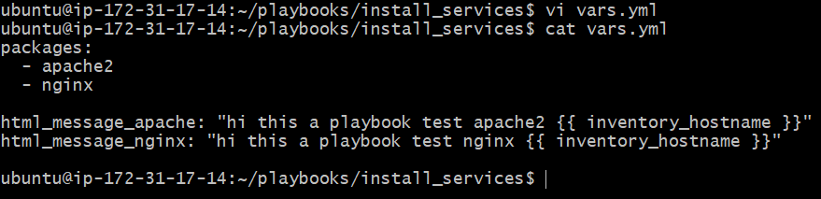

index_apache.html
<!DOCTYPE html>
<html>
<head><title>Apache Test</title></head>
<body>
<h1>{{ html_message_apache }}</h1>
</body>
</html>

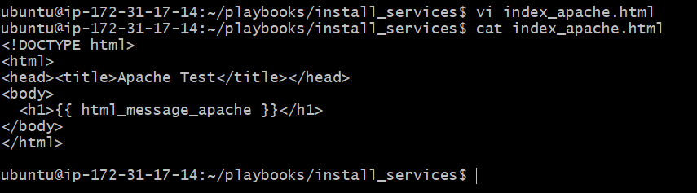

index_nginx.html
<!DOCTYPE html>
<html>
<head><title>Nginx Test</title></head>
<body>
<h1>{{ html_message_nginx }}</h1>
</body>
</html>

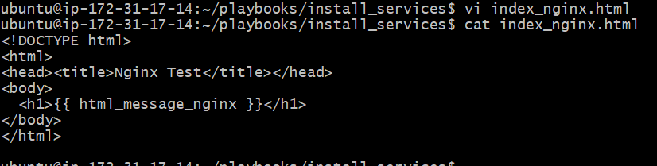

site.yml (main playbook)
---
- name: Install and configure Apache2 (80) and Nginx (82)
hosts: all
become: yes
vars_files:
- vars.yml

tasks:
- name: Install Apache2 and Nginx
apt:
name: "{{ packages }}"
state: present
update_cache: yes

- name: Deploy Apache HTML page
template:
src: index_apache.html
dest: /var/www/html/index.html
mode: '0644'

- name: Deploy Nginx HTML page
template:
src: index_nginx.html
dest: /var/www/html/index.nginx.html
mode: '0644'

- name: Configure Nginx to run on port 82 and serve custom index
blockinfile:
path: /etc/nginx/sites-available/default
marker: "# {mark} ANSIBLE MANAGED BLOCK"
block: |
server {
listen 82 default_server;
listen [::]:82 default_server;
root /var/www/html;
index index.nginx.html;
server_name _;
location / {
try_files $uri $uri/ =404;
}
}

- name: Test Nginx configuration
command: nginx -t
register: nginx_test
changed_when: false
failed_when: nginx_test.rc != 0

- name: Restart both services
service:
name: "{{ item }}"
state: restarted
enabled: yes
loop:
- apache2
- nginx

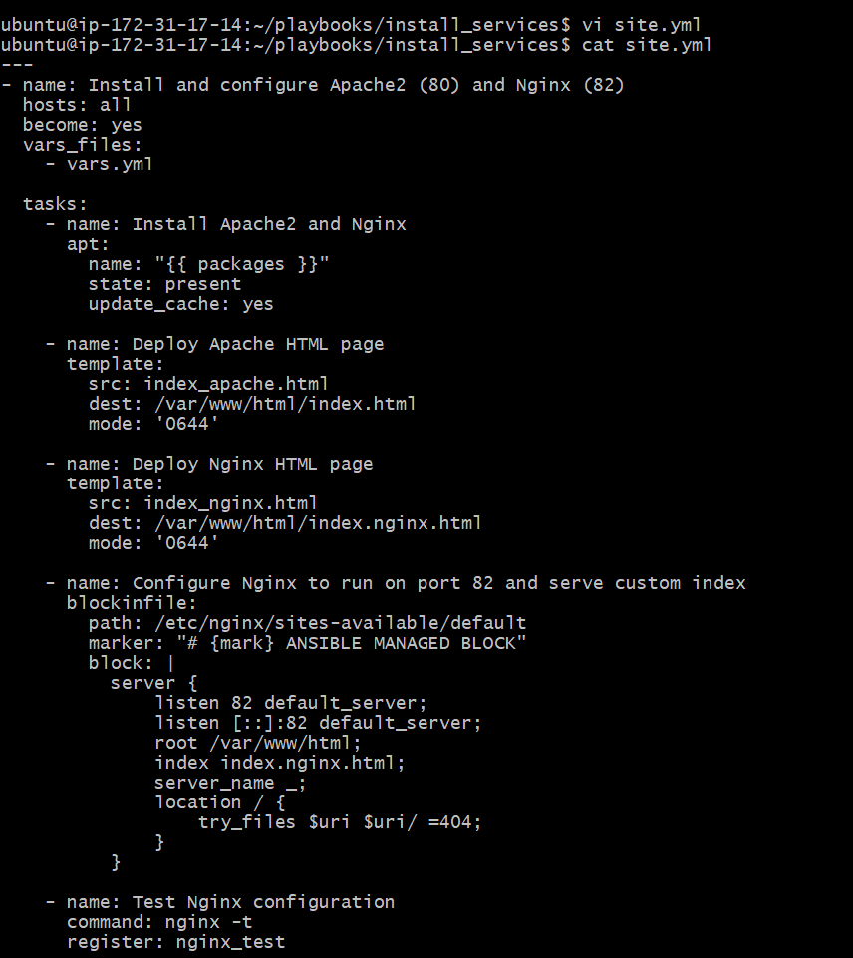

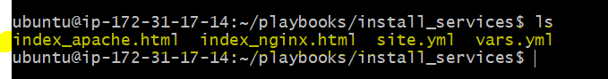
ansible-playbook site.yml --syntax-check – To check the syntax.
ansible-playbook site.yml --check – To dry run and know the output.
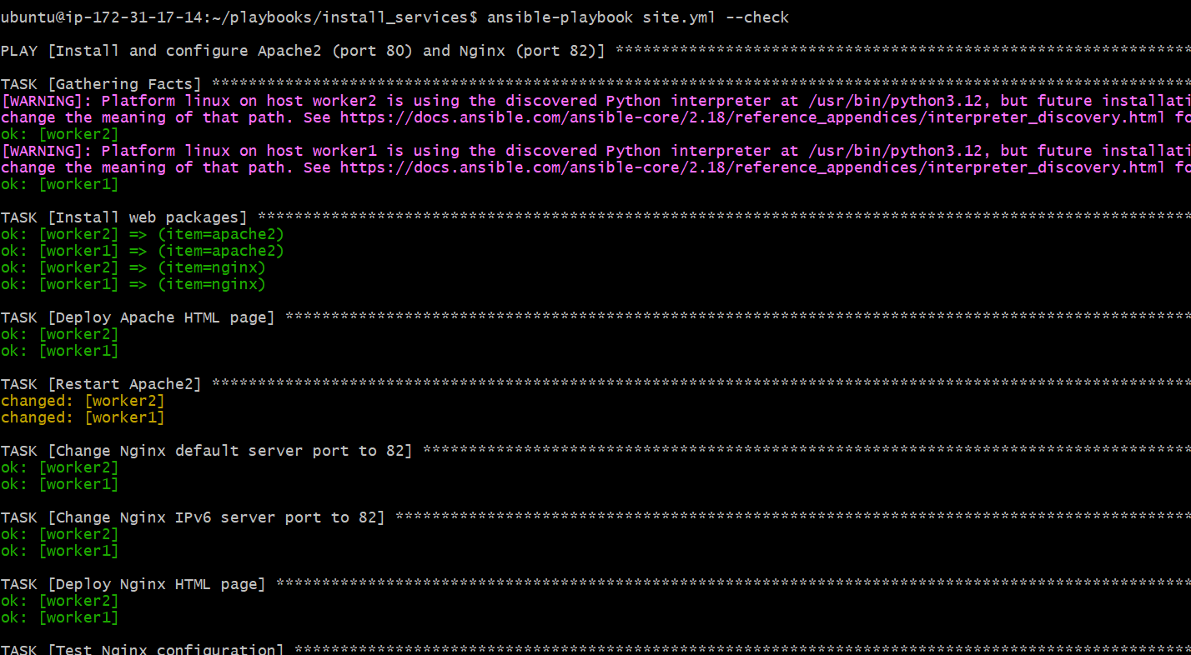

ansible-playbook site.yml – To run/execute the playbook.

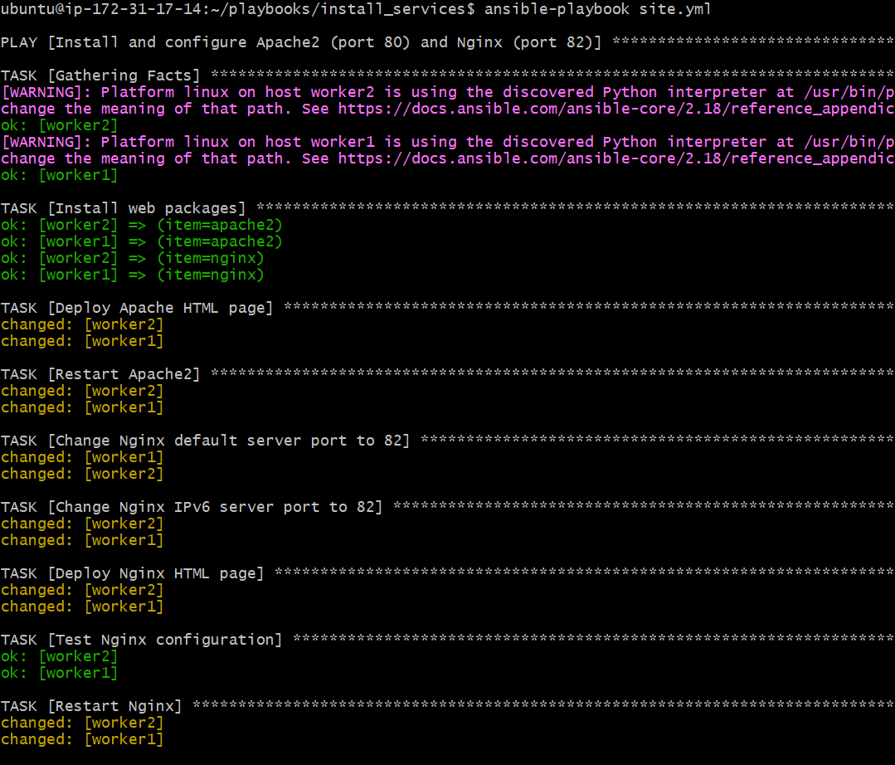

Let’s verify the output at worker-01 and worker-02:
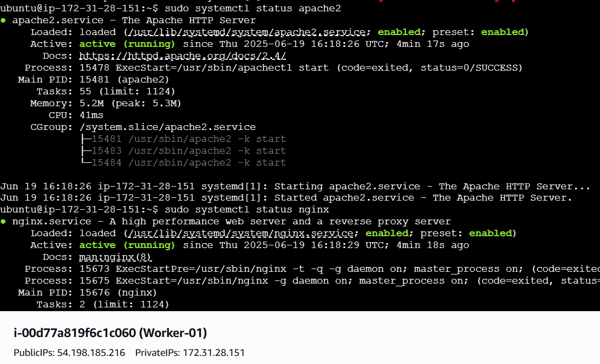
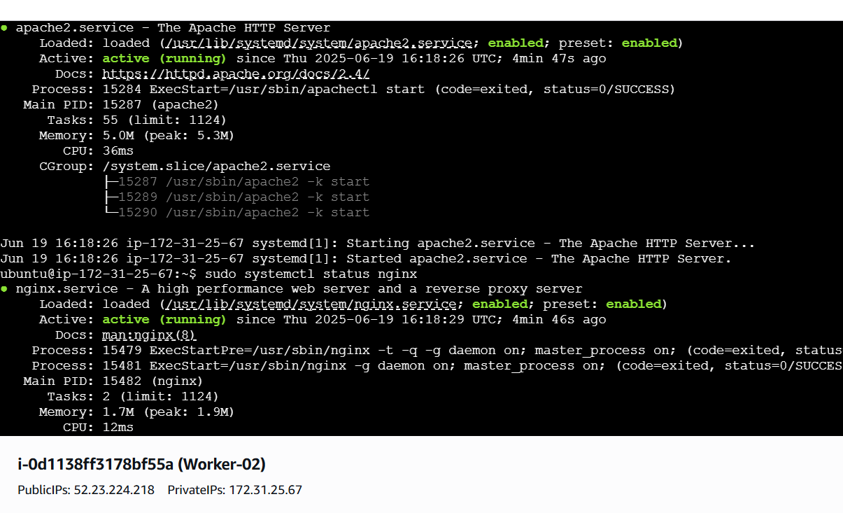

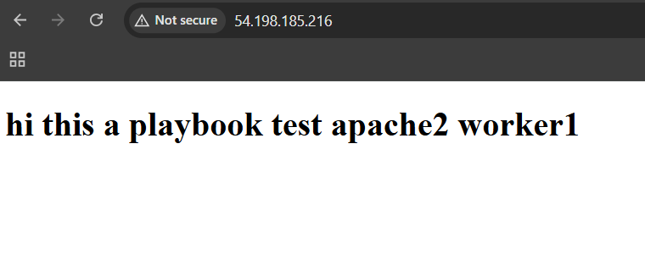


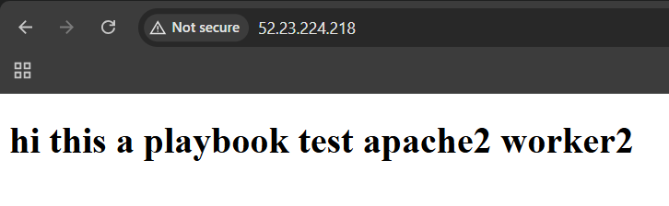



2) Ansible playbook to create 10 different directories with minimal code and directory names should be passed as variables.

Playbook: Create 10 Directories with Inline Variable

10directories.yml
---
- name: Create 10 directories from inline variable
hosts: all
become: yes
vars:
dir_list:
- /opt/demo1
- /opt/demo2
- /opt/demo3
- /opt/demo4
- /opt/demo5
- /opt/demo6
- /opt/demo7
- /opt/demo8
- /opt/demo9
- /opt/demo10

tasks:
- name: Create multiple directories
file:
path: "{{ item }}"
state: directory
mode: '0755'
loop: "{{ dir_list }}"

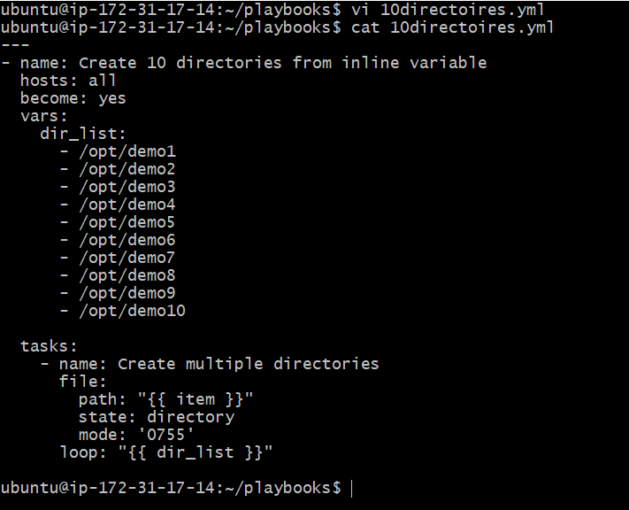
ansible-playbook 10directories.yml --syntax-check – To check the syntax.

ansible-playbook 10directories.yml --check – To dry run and know the output.
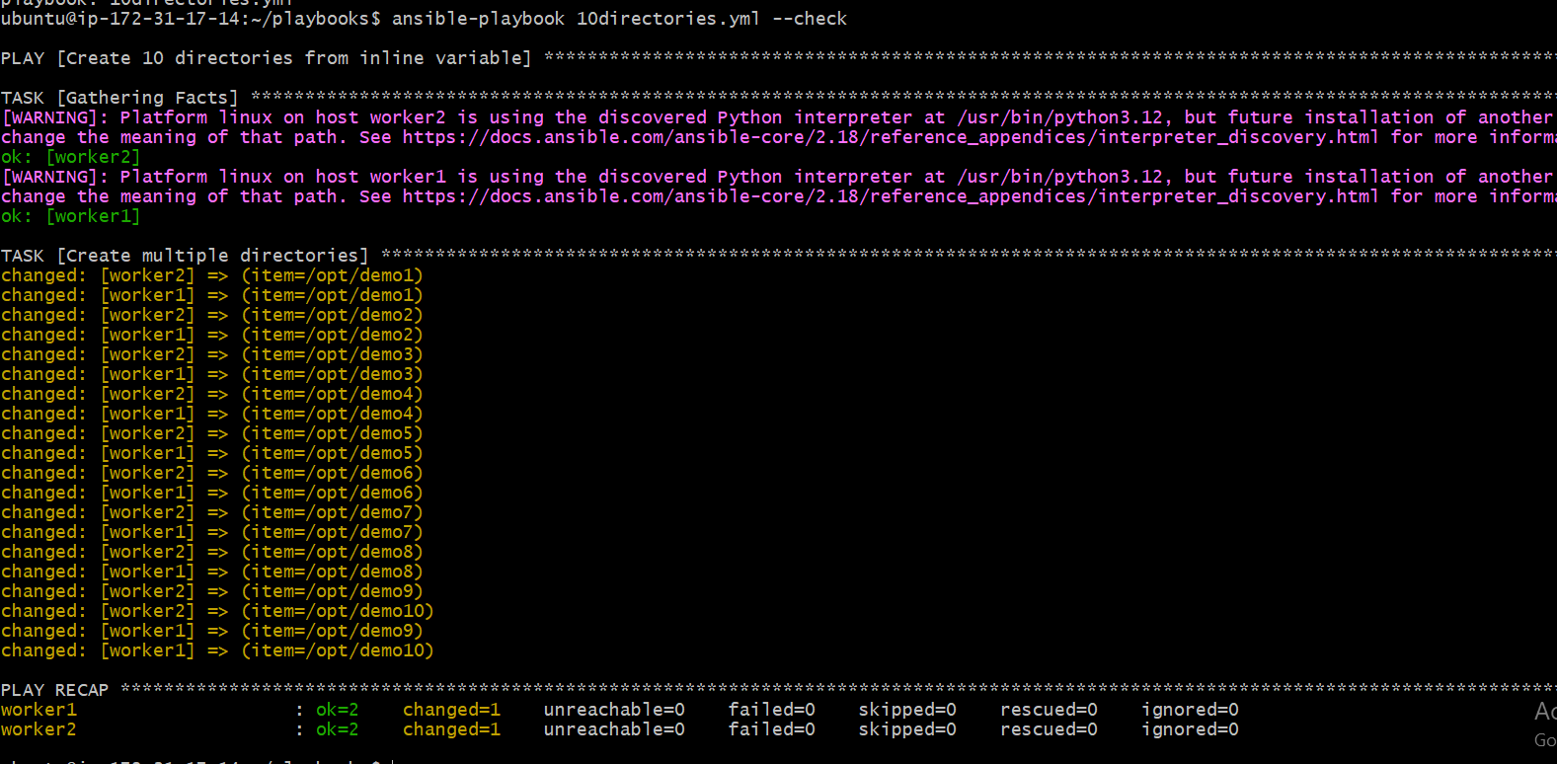

ansible-playbook 10directories.yml – To run/execute the playbook.
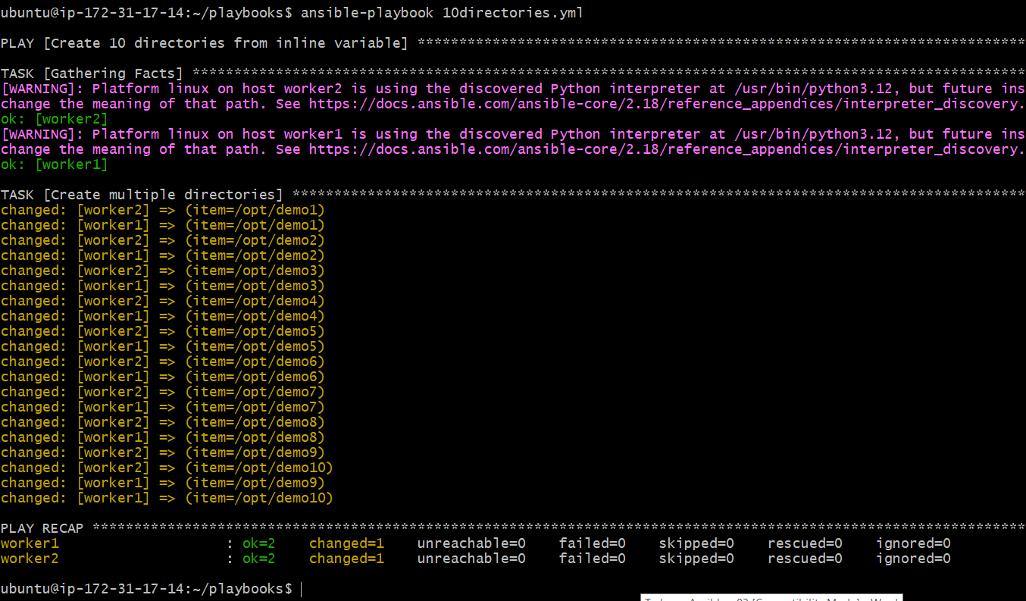

Let’s verify the output at worker-01 and worker-02:

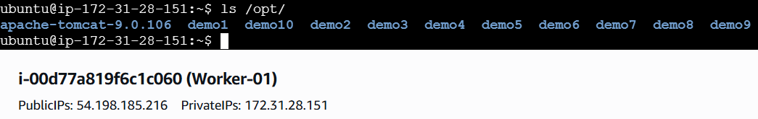

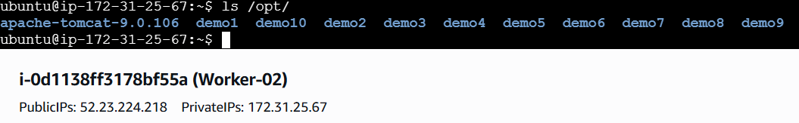

3) Ansible playbook to copy ssh-keygen from master to worker nodes.
Note:
a)Provision new 3 ec2 machines, one master and two worker nodes.
b)Create common user called ansadm and provide sudo priviliges on 3 ec2 instances.
c)Create ssh-keygen in master and your playbook should copy the keygen making it password less authentication.

Create Inventory File
Create a file called inventory.ini:
[master]
localhost ansible_connection=local ansible_user=ubuntu

[workers]
worker1 ansible_host=172.31.28.151 ansible_user=ubuntu
worker2 ansible_host=172.31.25.67 ansible_user=ubuntu

[all:vars]
ansible_python_interpreter=/usr/bin/python3

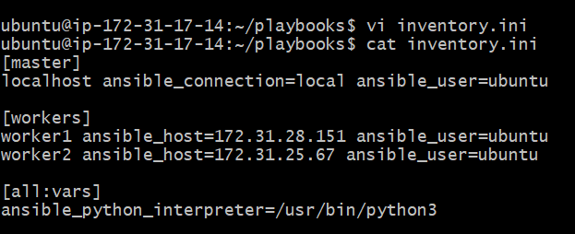

Ansible Playbook — ssh_key_copy.yml
Create the following playbook:
---
- name: Step 1 - Create 'ansadm' user with sudo on all nodes
hosts: all
become: true
tasks:
- name: Create ansadm user
user:
name: ansadm
groups: sudo
shell: /bin/bash
create_home: yes
append: yes

- name: Allow passwordless sudo for ansadm
copy:
dest: /etc/sudoers.d/ansadm
content: 'ansadm ALL=(ALL) NOPASSWD:ALL'
mode: '0440'

- name: Step 2 - Generate SSH key on master for ansadm
hosts: master
become: true
tasks:
- name: Ensure .ssh directory exists for ansadm
file:
path: /home/ansadm/.ssh
state: directory
owner: ansadm
group: ansadm
mode: '0700'

- name: Generate SSH key for ansadm if not exists
command: sudo -u ansadm ssh-keygen -t ed25519 -f /home/ansadm/.ssh/id_ed25519 -N ""
args:
creates: /home/ansadm/.ssh/id_ed25519

- name: Step 3 - Copy public key from master to worker nodes
hosts: workers
become: true
vars:
ssh_key_path: /home/ansadm/.ssh/id_ed25519.pub
tasks:
- name: Read master's public key
delegate_to: localhost
become: true
slurp:
src: "{{ ssh_key_path }}"
register: pubkey_data

- name: Add master's key to authorized_keys of ansadm
authorized_key:
user: ansadm
key: "{{ pubkey_data.content | b64decode }}"
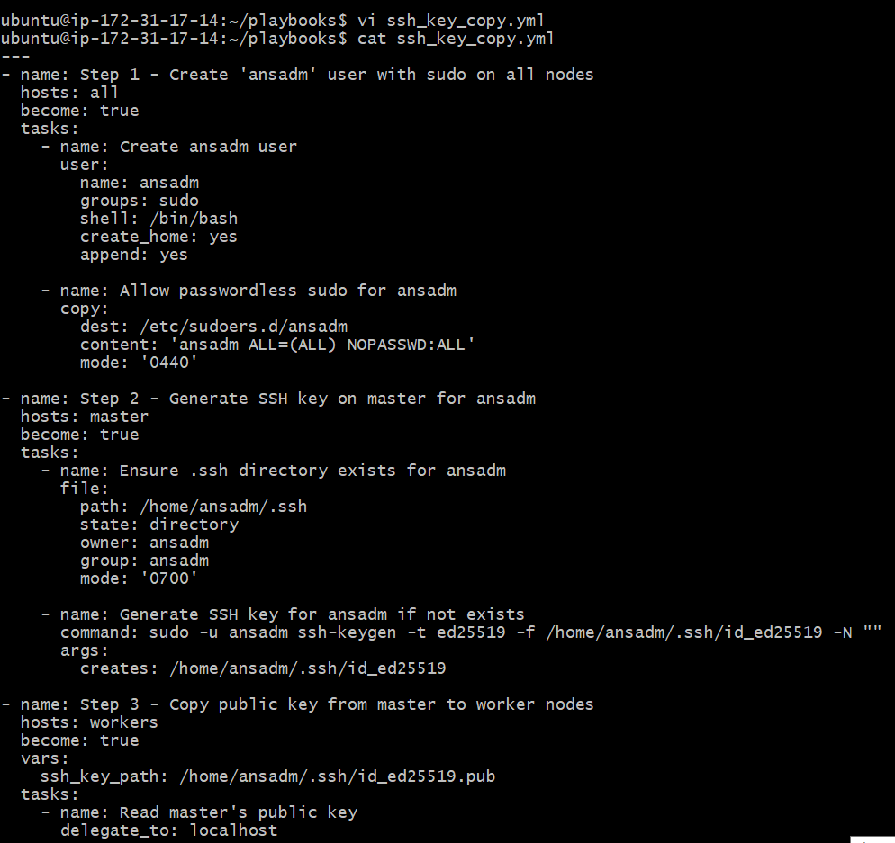

Run the Playbook
Make sure you're in the directory with both inventory.ini and ssh_key_copy.yml.
Run:
ansible-playbook -i inventory.ini ssh_key_copy.yml

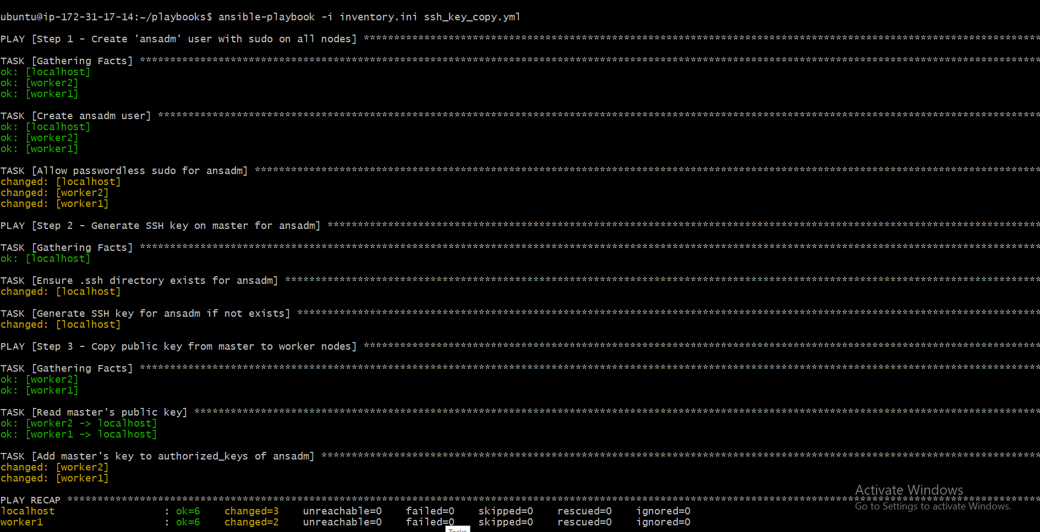

Let’s verify the output at worker-01 and worker-02:

Test Passwordless SSH
On the master node, switch to the ansadm user and test SSH:
sudo -i -u ansadm

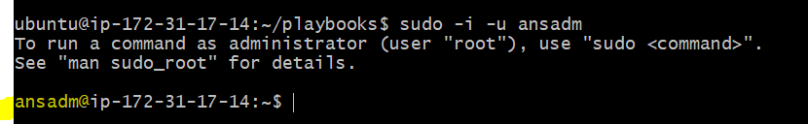

sh worker1
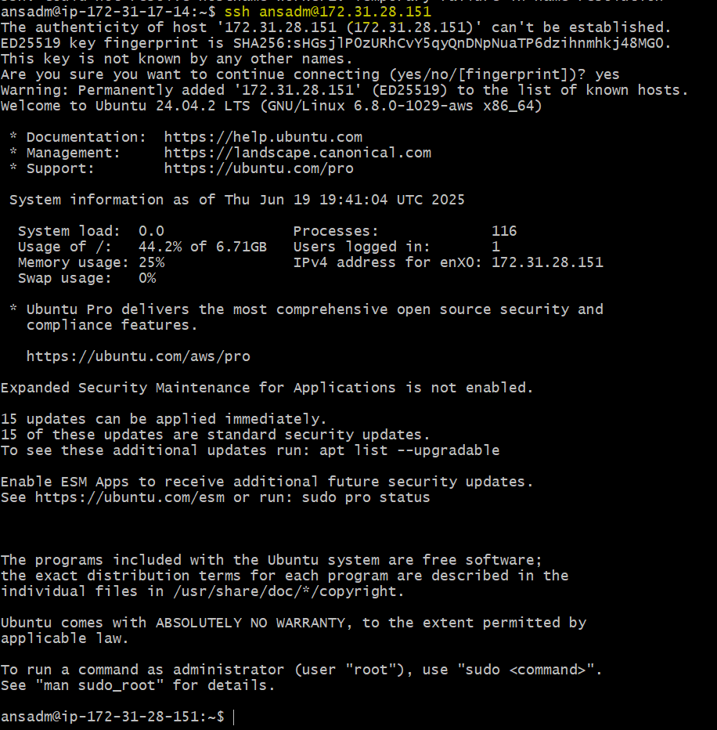

ssh worker2
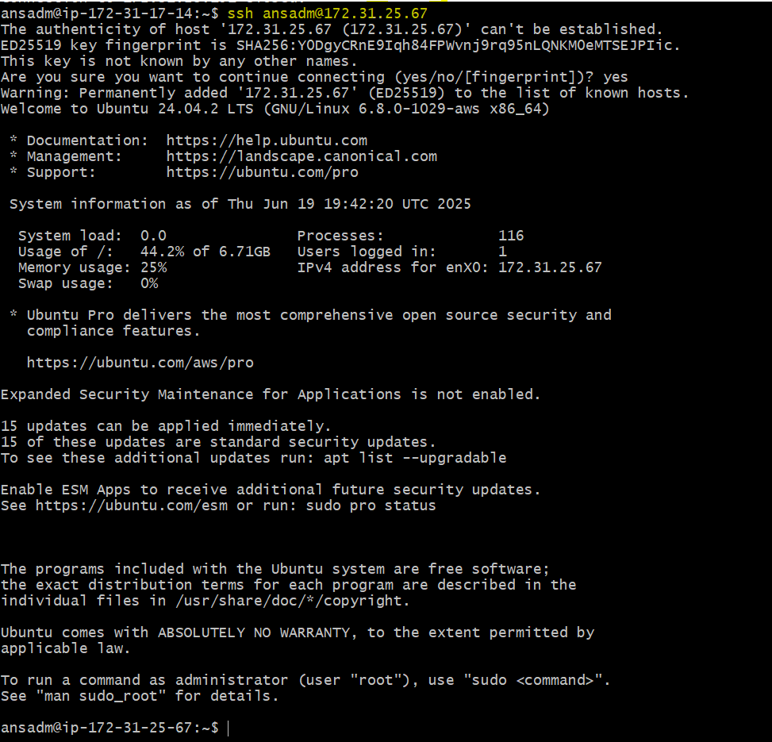

Verification Command:
To verify Ansible is working over SSH:
Need to add inventory file for this user:
[master]
localhost ansible_connection=local ansible_user=ansadm

[workers]
worker1 ansible_host=172.31.28.151 ansible_user=ansadm
worker2 ansible_host=172.31.25.67 ansible_user=ansadm

[all:vars]
ansible_python_interpreter=/usr/bin/python3
ansible all -i inventory.ini -m ping -u ansadm

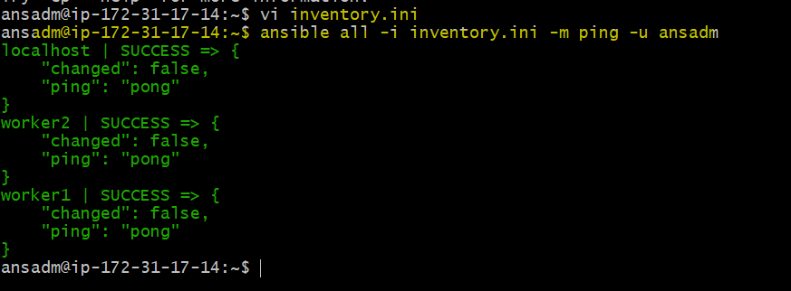

4) Ansible playbook to inject ansible vault variables.

Create a Vault-Encrypted Variable File
ansible-vault create vault.yml

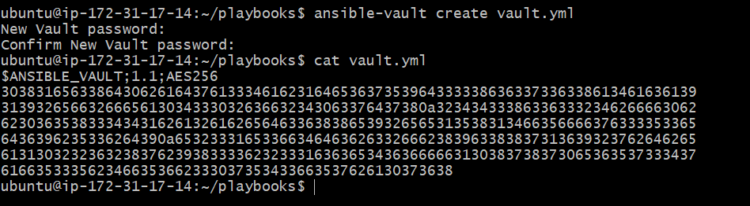
Add content like:
db_user: mubeen
db_password: S3cretP@ssw0rd

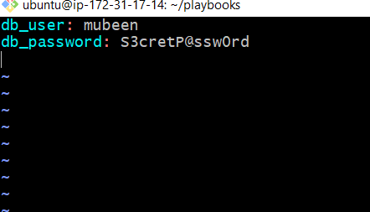
Save and exit.

Use Encrypted Variables in a Playbook
vault_injection.yml
---
- name: Inject Ansible Vault variables and use them
hosts: all
become: true
vars_files:
- vault.yml

tasks:
- name: Show database username
debug:
msg: "Database user is {{ db_user }}"

- name: Save password to file (example use of secret)
copy:
content: "Password is {{ db_password }}"
dest: /tmp/secret.txt
mode: '0600'
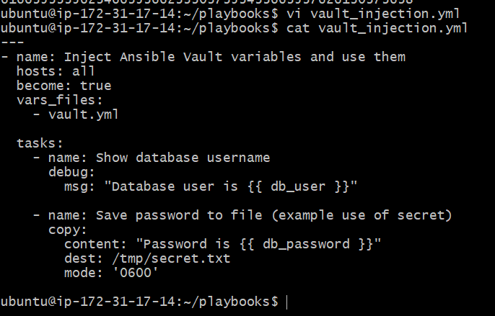
ansible-playbook vault_injection.yml --ask-vault-pass – To run/execute the playbook with asking for vault password.
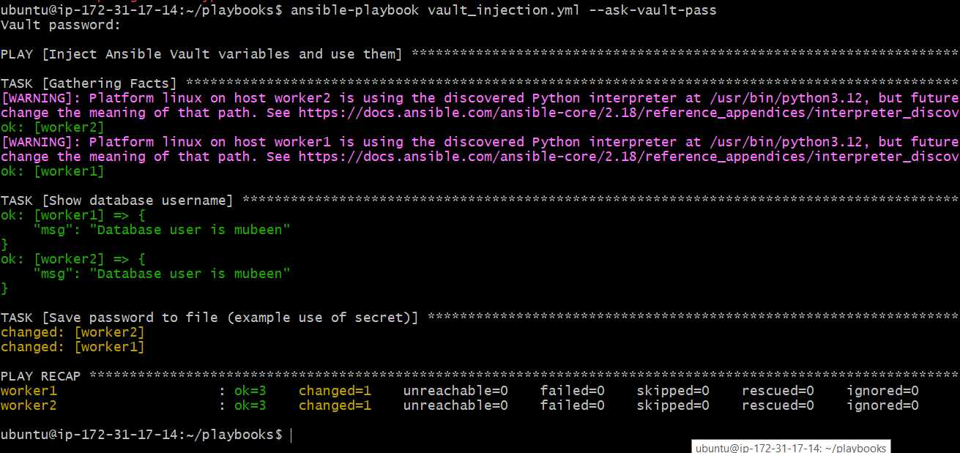

Let’s verify the output at worker-01 and worker-02:
The password will exist on the worker node in plain text — even though it came from an Ansible Vault file.
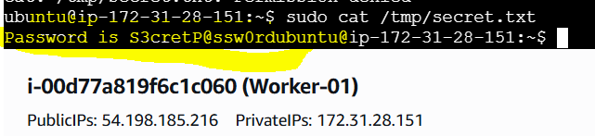

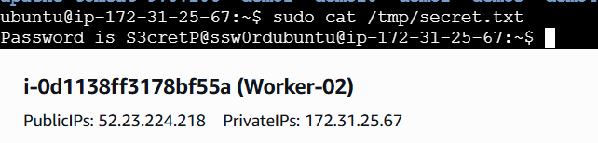

Why Secrets Might Be Needed on Worker Nodes (Real-Time Use Cases)
Case | Why it's needed
🔐 Database connection | Web/app server (worker) must connect to DB → needs DB user/pass in config
🔐 External API key | App running on worker calls an external API (e.g., payment, SMS, monitoring)
🔐 Local user creation | You provision Linux users via Ansible and set initial passwords
🔐 TLS/SSL keys | You’re deploying certs for Apache/Nginx
🔐 Private repo auth | Worker needs GitHub/Docker token to pull private repos or images
In these cases, you use Ansible Vault to encrypt the secrets, and the playbook injects them into the worker securely at deploy time.

When We Use Vault Only on the Master (Control Node)
Ansible Vault is used on the master node to:
- 🔐 Store and protect secrets securely (e.g., credentials, tokens, passwords)
- 📦 Keep secrets encrypted inside playbooks, variable files, or group_vars
- 🛡️ Prevent secrets from being exposed in Git repos or CI logs
🚫 Secrets remain encrypted and never leave the master unless explicitly sent via a playbook task
THE-END

